COLLEGEX

Real Time Project

Bachelor of Technology (B.Tech – II Year / II Semester)

in
Computer Science and Engineering

By

B.Yashika - 22AG1A05D2
M.Rama Sai Kiran - 22AG1A05G6
K.Manideep - 22AG1A05F7

Under the Esteemed Guidance of
Mr P.Satish Bhasker
Assistant Professor

Department of Computer Science and Engineering
ACE Engineering College
An AUTONOMOUS Institution
NBA Accredited B. Tech Courses, Accorded NAAC 'A' Grade
(Affiliated to Jawaharlal Nehru Technological University, Hyderabad, Telangana)
Ankushapur(V), Ghatkesar(M), Medchal - MalkajgiriDist - 501 301.
JULY 2024

ACE Engineering College
An AUTONOMOUS Institution
Website: www.aceec.ac.in E-mail: info@aceec.ac.in

Department of Computer Science and Engineering

Certificate
This is to certify that the Real Time project work entitled "COLLEGEX" submitted by
B. Yashika (22AG1A05D2), M. Rama Sai Kiran(22AG1A05G6), K. Manideep(22AG1A05F7) in partial fulfillment of Real Time Project work during the academic year 2023-24 is a record of bonafide work carried out by them under our guidance and supervision.

Internal Guide Project Coordinator Mr P. Satish Bhasker Mr. B R Srinivasa Rao
Assistant Professor Assistant Professor

Head of the Department
Dr. M. V. Vijaya Saradhi
Professor and Head
Department of CSE

Acknowledgement

We would like to express our gratitude to all the people behind the screen who have helped us transform an idea into a real time application.
We would like to express our heart-felt gratitude to our parents without whom we would not have been privileged to achieve and fulfill our dreams.
A special thanks to our General Secretary, Prof. Y. V. Gopala Krishna Murthy, for having founded such an esteemed institution. Sincere thanks to our Joint Secretary
Mrs. M. Padmavathi, for support in doing project work. We are Deeply grateful to our beloved Principal, Dr. B. L. Raju for permitting us to carry out this project.
We are profoundly grateful to Dr. M. V. Vijaya Saradhi, Professor and Head, Department of Computer Science and Engineering, for being an excellent guide and also a great source of inspiration to our work.
We are extremely thankful to Mr. B R Srinivasa Rao, Assistant Professor and Project Coordinator, who helped us throughout our Real-Time / Field Based Research Project.

We are very thankful to our Internal Guide Mr P. Satish Bhasker, Assistant Professor who has been an excellent guide and also given continuous support for the Completion of our project work.
The satisfaction and euphoria that accompany the successful completion of the task would be great, but incomplete without the mention of the people who made it possible, whose constant guidance and encouragement crown all the efforts with success. In this context, We would like to thank all the other staff members, both teaching and non-teaching, who have extended their timely help and eased our task.

B.Yashika (22AG1A05D2)
M.Rama Sai Kiran (22AG1A05G6)
K. Manideep (22AG1A05J0)




ACE
Engineering College
An Autonomous Institution
Ghatkesar, Medchal (Dist), Hyderabad, Telangana State - 501 301
(NBA Accredited B.Tech Courses, Accorded NAAC 'A' Grade)
Department of Computer Science and Engineering
Real Time Project
INDEX
CONTENTS Page No
Abstract 1
Feasibility Study
•Technical Feasibility 2
• Financial Feasibility 2
• Product Feasibility 2
Literature Survey & Practical observation 3
1. Introduction
1.1 Purpose 5
1.2 Scope 5
1.3 Real-Time usage & Applications 6
1.4 Target Audience 6
2. Overall Description
2.1 User Interfaces& Characteristics 8
2.2 System Interfaces& Communication Interfaces 9
3. System Analysis
3.1 Existing System& Draw backs 10
3.2 Proposed System& Overcoming draw backs 10
3.3 Team Size 11
4. Software and Hardware requirements 12
5. Software Design 13
6. Module Description 17
7. Implementation (Pseudo Code) 18
8. Test Cases 27
9. Output Screens 29
10. Conclusion 34
11. Future enhancements 35
12. References 36

ABSTRACT

COLLEGEX is an innovative website designed to enhance communication between students and faculty members. The platform offers a set of features including result checking, attendance tracking, timetable management, event notifications, and access to a repository of previous exam papers. For students, College X provides a centralized hub to access their academic performance, enabling them to view results and attendance records conveniently.

Additionally, students can stay organized with personalized timetables and stay informed about upcoming events. The availability of previous exam papers facilitates effective exam preparation, contributing to improved learning outcomes. Faculty members benefit from efficient administrative tools, accessing student data seamlessly and managing course schedules effectively through College X. The intuitive interface ensures user-friendly navigation for both students and faculty members, promoting College accessibility across various devices.

The previous exam papers also supports students in their exam preparation. Faculty members, on the other hand, can efficiently manage course schedules and access student data through the platform, including a convenient one-click call feature to contact parents directly. The user-friendly interface of College X ensures accessibility for both students and faculty members across different devices.

FEASIBILITY STUDY

1.Technical Feasibility: Evaluate the technical requirements and capabilities needed to develop the system.
Considerations: Technology stack (MongoDB), server requirements, software tools.
2.Financial Feasibility: Analyze the budget required for development, deployment, and maintenance.
Considerations: Cost of hosting, software licenses, developer salaries.
3.Product Feasibility: Assess the overall viability of the product in terms of market demand and user needs.
Considerations: Similar products in the market, potential user base, benefits over existing solutions.

LITERATURE SURVEY & PRACTICAL OBSERVATION

- Overview of Leave Management Systems:
  - Introduction: College Management Systems (CMS) streamline the management of academic and administrative tasks within educational institutions. Effective CMS enhances operational efficiency, data management, and compliance with institutional policies.
  - Existing Systems: Review popular CMS solutions such as "Blackboard," "Moodle," and "Schoology." Analyze their features including student information management, course management, attendance tracking, examination management, and reporting capabilities.
- Technologies and Frameworks:
  - React.js in Web Development: Discuss the choice of React.js for developing the CollegeX Portal. Highlight React.js benefits such as component-based architecture, virtual DOM, extensive community support, and integration capabilities compared to other frameworks like Angular and Vue.js.
  - Database Management: Evaluate MySQL as the database solution for storing and managing user data, leave records, and other relevant information. Compare with alternatives like PostgreSQL and MongoDB.
- User Management and Authentication:
  - Role-Based Access Control (RBAC): Importance of implementing RBAC to differentiate between administrators, faculty, and students. Ensuring secure access and proper management of user roles.
  - Authentication Methods: Review various authentication methods including JWT (JSON Web Tokens) and OAuth. The choice of authentication strategy for the CollegeX Portal.
- Leave Application and Approval Process:
  - Workflow Design: Examination of key workflows such as student registration, course enrollment, attendance tracking, and result management. Key stages include data entry, review, approval/rejection, and notification.
  - Notification Systems: Analysis of notification mechanisms like email alerts and SMS notifications to keep users informed about important updates and actions required.
- User Experience and Interface Design:
  - UI/UX Principles: Importance of intuitive and user-friendly interface design. Best practices in creating a responsive and accessible web application using React.js and HTML/CSS.
  - Case Studies: Review of user feedback and interface designs from existing CMS to identify strengths and areas for improvement.
- Security and Data Privacy:
  - Data Security: Overview of security measures to protect user data. Importance of encryption, secure communication (HTTPS), and regular security audits.
  - Compliance with Regulations: Ensuring the system complies with data protection regulations such as GDPR and local data privacy laws.

Practical Observation
- Development and Implementation:
  - System Design: Observations from the design and implementation phase of the CollegeX Portal. Challenges faced and solutions implemented during the development process using React.js.
  - Coding Practices: Best practices in coding, version control, and project management. Use of tools like Git for collaboration and maintaining code quality.
- User Interaction and Feedback:
  - Usability Testing: Conduct usability tests with a sample group of students, faculty, and administrators. Gather feedback on the system’s ease of use, functionality, and overall user experience.
  - Iterative Improvements: Make iterative improvements based on user feedback. Document changes and assess their impact on the system’s performance and user satisfaction.
- System Performance:
  - Load Testing: Observations from load testing to ensure the system can handle multiple simultaneous users. Identify and address performance bottlenecks.
  - Response Time and Reliability: Measure the response time and reliability of the system under different scenarios. Ensure the system remains responsive and available.
- Integration and Deployment:
  - Deployment Challenges: Practical challenges faced during the deployment of the CollegeX Portal. Steps taken to ensure a smooth deployment process.
  - Integration with Existing Systems: Observations from integrating the CollegeX Portal with other institutional systems such as student information systems and email servers.
- Maintenance and Support:
  - Ongoing Maintenance: Strategies for ongoing maintenance and support. Importance of regular updates, bug fixes, and user support mechanisms.
User Training and Documentation: Providing training and documentation to users for effective use of the system. Ensuring users are well-equipped to navigate and utilize the portal.

- INTRODUCTION

College X is a comprehensive college management system designed to streamline administrative processes, enhance communication channels, and provide academic support for students and faculty. By leveraging modern technology, College X aims to improve efficiency, facilitate decision-making, and create a environment for teaching, learning, and research. College X is a robust platform that integrates various functionalities, enhance communication channels, and provide academic support for students and faculty members.

  - Purpose:
College X aims to address the complex challenges faced by colleges and universities in managing their day-to-day operations. The primary purpose of College X is to:
Simplify administrative tasks: By automating processes such as student enrollment, course scheduling, attendance tracking, and result management, College X reduces administrative burden and enhances efficiency.
Improve communication: College X provides intuitive communication tools that facilitate seamless interaction between students, faculty members, administrative staff, and parents, fostering collaboration.
Enhance academic support: With feature like previous question papers, College X empowers students and faculty members with the resources they need to succeed academically.

1.2 Scope
College X offers a wide range of functionalities to meet the diverse needs of colleges and universities These include:
Student Management: From enrollment to graduation, CollegeX manages all aspects of student information, including admissions, registration, academic records, financial aid, and student services.
Faculty Management: College X streamlines faculty recruitment, scheduling, performance evaluation, professional development, and collaboration, ensuring that colleges have the best faculty members to support student learning.
Attendance Tracking: With CollegeX, colleges can easily monitor student attendance, participation, and engagement in classes and extracurricular activities, promoting accountability and student success.
Result Management: CollegeX facilitates the recording, analysis, and management of student grades, assessments, evaluations, and academic performance, ensuring fair and transparent evaluation processes.
Library Management: CollegeX provides seamless access to library resources, including digital collections, cataloging, circulation, research tools, and smart copies of books, empowering students and faculty members with the knowledge they need to excel academically.
One-Click-call: Facilitating instant communication between faculty and parents with a single click, enhancing parent-teacher interaction and support.

1.3. REAL-TIME USAGE & APPLICATIONS
A COLLEGEX is a comprehensive software solution designed to streamline and manage the day-to-day operations of a college or university. Here are some real-time applications and uses of a college management system
1. Time table: Helps in managing academic programs, curriculum, timetables, and faculty allocation. It facilitates grading.
2. Attendance: Provides real-time attendance data to track student presence, notify absentees, and generate attendance reports for faculty and administration.
3.One Click Call: Facilitates communication between students, faculty, and administration through announcements, messaging, forums, and discussion boards. Supports collaborative tools for group projects and assignments.
4. Result: Handles examination scheduling, result processing. Generates grade reports and performance analysis.
Overall, a college management system enhances efficiency, transparency, and communication within educational institutions, enabling them to focus more on academic excellence and student development.

1.4. TARGET AUDIENCE
The target audience of a COLLEGEX includes various stakeholders within educational institutions:
1. Faculty and Instructors: Academic staff who deliver courses, conduct assessments, manage student progress, and require tools for curriculum planning, grading, and communication with students.
2. Students: Enrolled students who utilize the system for course registration, accessing academic records, checking schedules, submitting assignments, and communicating with faculty and peers.
The CMS serves as a central hub that connects these diverse stakeholders, providing them with necessary tools and information to fulfill their respective roles effectively within the educational institution.

2. OVERALL DESCRIPTION
2.1 User Interfaces & Characteristics
A collegeX typically encompasses a variety of user interfaces to cater to the diverse needs of students, faculty, administrators, and other stakeholders. Here are some common user interfaces you might find in a college management system:
1. Administrator Dashboard: Administrators, such as college staff and management, use this interface to oversee various aspects of the college's operations.
2. Library System: The library interface allows users to search the library catalog, check out and return books, access online resources (like e-books and databases).
3. Human Resources: Portal Faculty and staff use this interface to manage personal information, benefits, leave requests, and professional development opportunities.
4. Feedback and Support: A help desk or support interface allows users to report technical issues, request assistance, and provide feedback.
These interfaces can vary in complexity and functionality depending on the specific needs and resources of the college or university. Additionally, modern college X often strive to provide a seamless and intuitive user experience across different devices, such as desktop computers, laptops, tablets, and smartphones.
CHARACTERISTICS:
Students:
This interface allows students to access their academic information, such as class schedules, grades, course registration. It may also include features for communication with professors, submitting assignments, and accessing course materials.
Faculty:
Faculty members use this interface to manage courses, upload course materials, record grades, communicate with students, and perform administrative tasks related to teaching. It may also include features for research administration, such as grant applications and publications tracking.

2.2 System Interfaces & Communication Interfaces
In a collegeX, system interfaces play a crucial role in enabling different components of the system to communicate with each other seamlessly. These interfaces facilitate the integration of various modules and ensure smooth operation of the entire system. Here are some key system interfaces you might find in a college management system:
1. Database Interface: This interface allows the collegeX to interact with the underlying database where all the data related to students, faculty, courses, grades to be stored.
2. Application Programming Interfaces (APIs): APIs enable communication between different software applications or modules within the college management system. They define the methods and data formats that applications can use to request and exchange information.
3. User Authentication Interface: This interface handles user authentication and authorization within the college management system. It verifies the identity of users (students, faculty, staff, administrators) and grants them appropriate access rights based on their roles and permissions. It may include functionalities for password management, multi-factor authentication, and single sign-on.
4. Integration Interfaces: These interfaces enable integration with external systems and services used by the college, such as student information systems, learning management systems, and library systems. They allow for the exchange of data and workflows between the collegeX and external systems, ensuring interoperability and data consistency.
5. Reporting Interface: This interface provides functionalities for generating and accessing reports and analytics within the collegeX. It allows administrators, faculty, and staff to extract relevant data, analyze trends, and make informed decisions based on insights derived from the system's data.
6. Configuration Interface: This interface allows administrators to configure and customize various aspects of the collegeX, such as user roles and permissions, academic policies, grading scales, course offerings, and system settings.

3. System Analysis

3.1 Existing System & Drawbacks
Traditional method involving physical paperwork for record-keeping. Faculty manually record attendance, grades, and other academic data. Timetables and event schedules are often displayed on notice boards. Limited accessibility and scalability. Prone to errors and data loss. Time-consuming administrative processes.

Limitations
1.Cost: Implementing and maintaining a comprehensive College Management System can be costly, especially for smaller educational institutions with limited budgets. Licensing fees, customization costs, and ongoing support expenses can add up.
2.Complexity: These systems can be complex to implement and use, requiring training for administrators, faculty, and staff. Users may find it challenging to navigate through the interface.
3.2 Proposed System & Overcoming Drawbacks:
College X is an integrated College Management System designed to modernize academic administration and communication within educational institutions. This comprehensive platform offers a wide range of features to meet the diverse needs of students, faculty.
Overcoming Drawbacks:
1.Result Management: Students can view their academic results in real-time, while faculty members can efficiently manage and update grades.
2.Attendance Tracking: Automated attendance tracking system for both students and faculty, promoting accountability and facilitating accurate record-keeping.
3.Timetable Management: Personalized timetables for students, with easy access to course schedules and class timings. Faculty members can manage their teaching schedules effectively.
4.Access to Previous Papers: Extensive repository of previous exam papers and study materials, enabling students to prepare effectively for assessments.
5.Security Measures: Robust security measures implemented to protect sensitive student data.
6.One-Click-call: Faculty can easily call parents with just one call. stem & Overcoming Drawbacks

3.3 Team Size
B. Yashika
M. Rama Sai Kiran
K. Manideep

4.SOFTWARE AND HARDWARE REQUREMENTS

Software:
1)Learning Management System (LMS)
2)Cloud Services
3)MongoDB
4) HTML, CSS, JS
5)Data encryption

Hardware:
1) servers
2) peripheral devices
3) security and backup solutions
4) Technical support
5) maintenance

5.SOFTWARE DESIGN
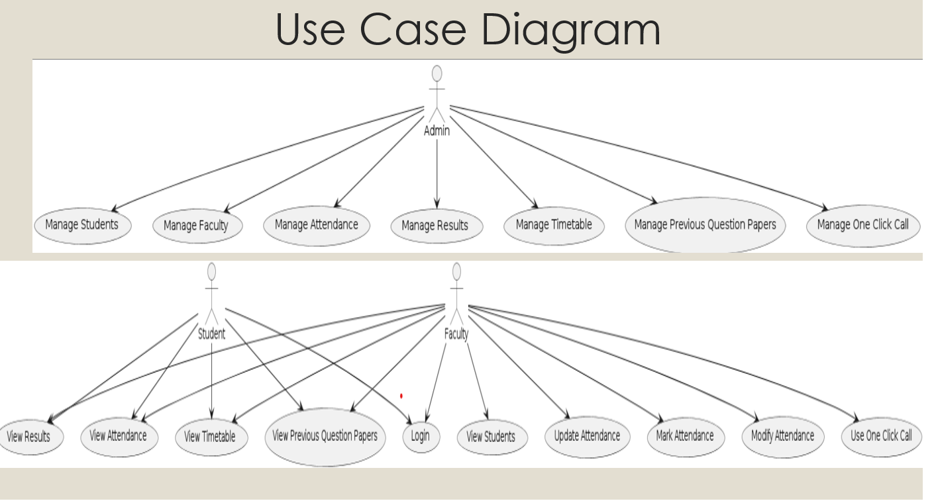

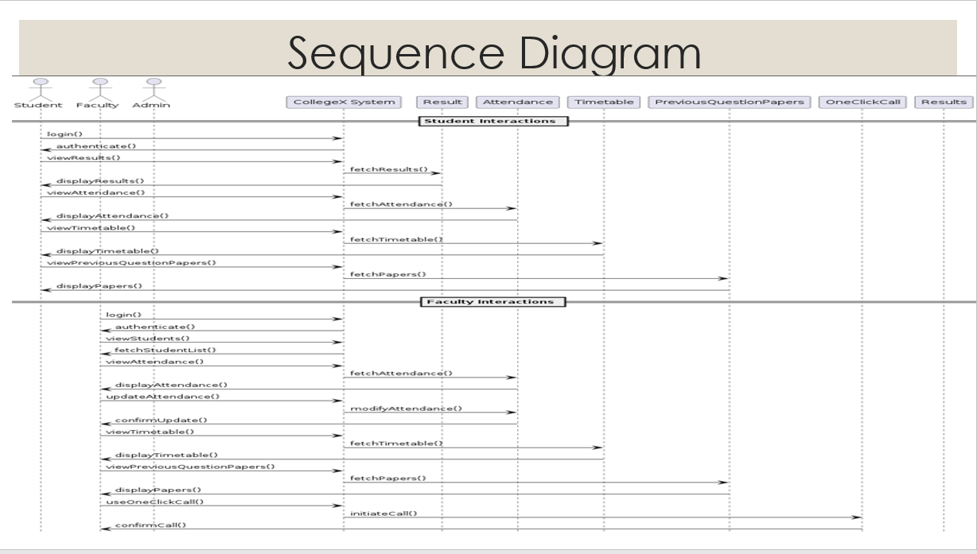

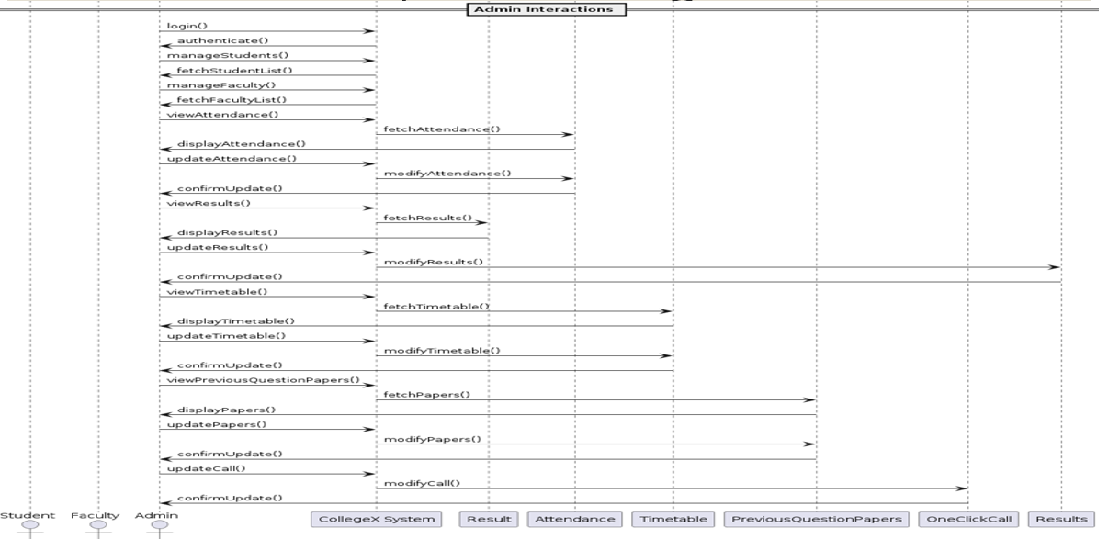

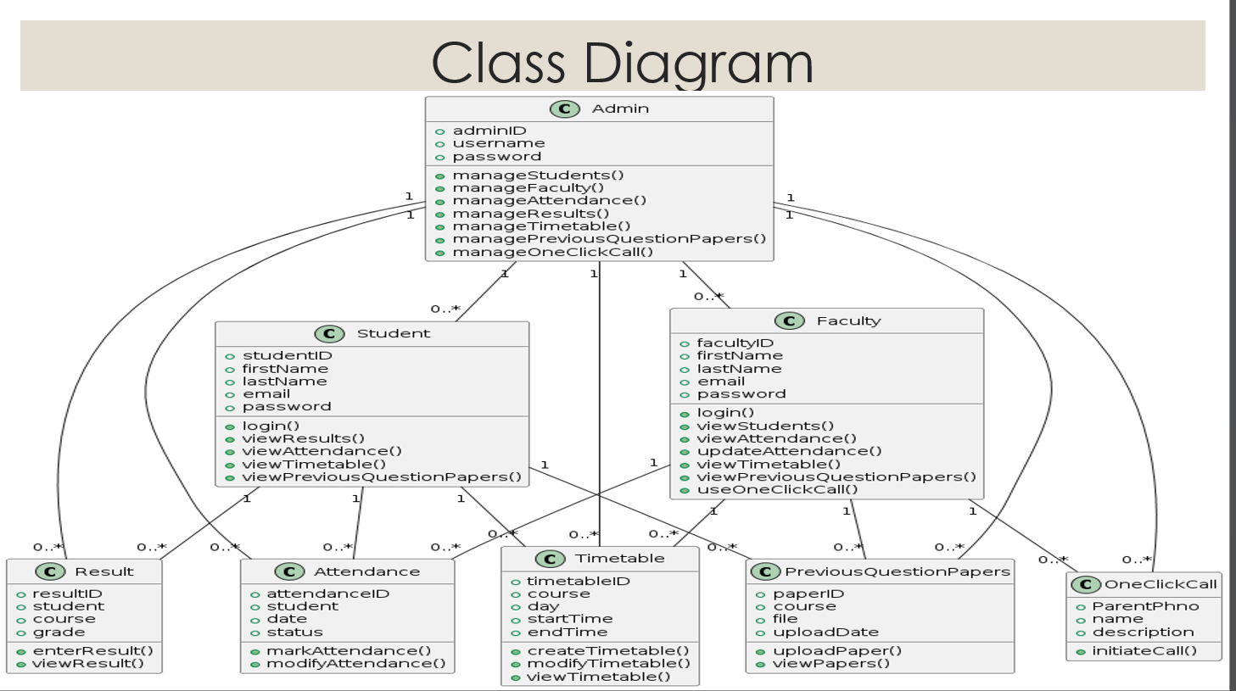

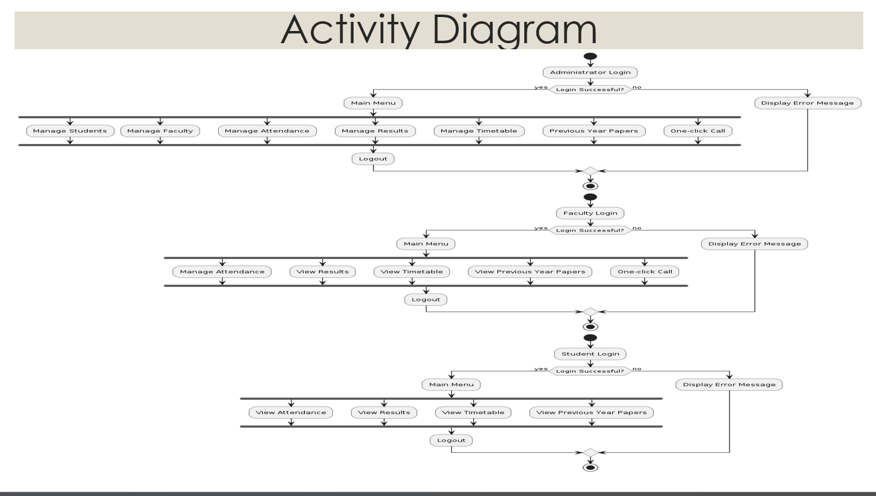

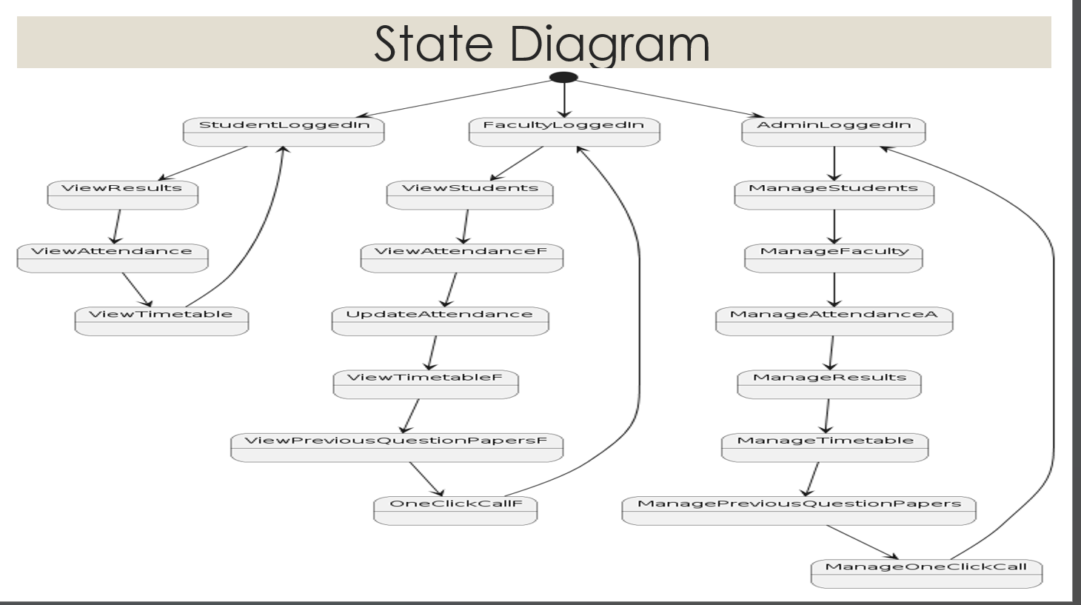

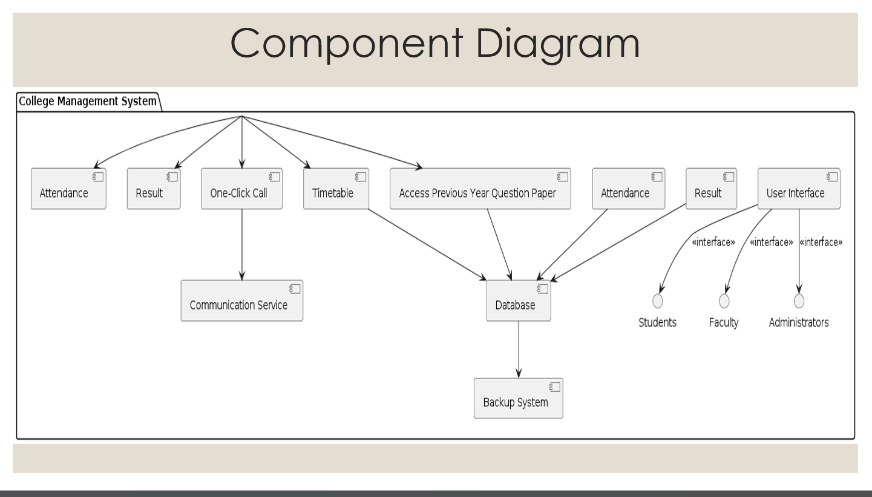

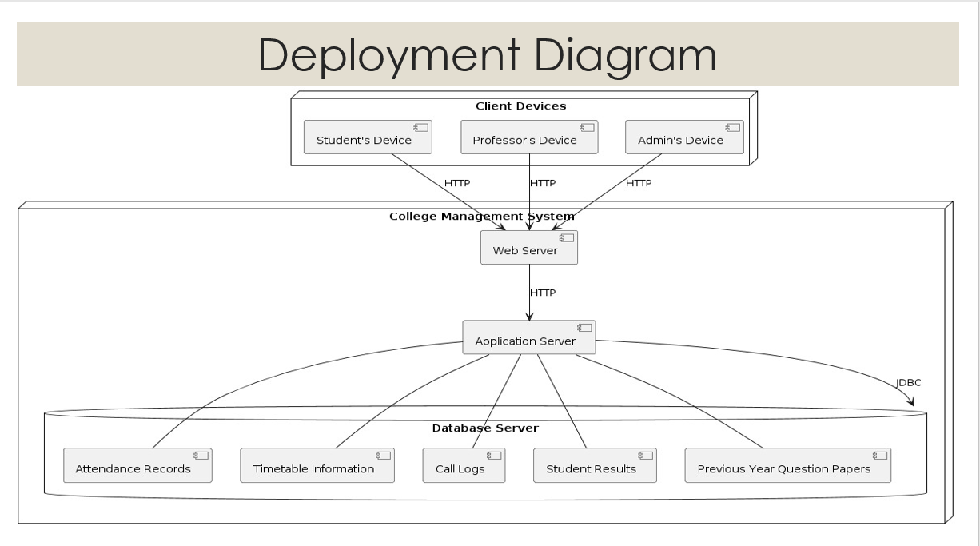

6.MODULE DESCRIPTION:
1. User Management Module
Description: This module handles user authentication, authorization, and management of different roles within the system.
Key Features:
User registration and profile management
Authentication mechanisms (e.g., username/password, single sign-on).
User activity login
2. Student Information System (SIS) Module
Key Features:
Academic record management (result).
Student attendance tracking.
Communication with students (e.g., announcements)
3. Faculty Management Module
Description: Handles faculty-related activities and information.
Key Features:
Faculty Communication with profile management.
Grading
faculty

7.IMPLEMENTATION:
<!DOCTYPE html>
<html lang="en">
<head>
<meta charset="UTF-8">
<meta http-equiv="X-UA-Compatible" content="IE=edge">
<meta name="viewport" content="width=device-width, initial-scale=1.0">
<title>Student Dashboard</title>
<link rel="shortcut icon" href="./images/logo.png">
<link href="https://fonts.googleapis.com/icon?family=Material+Icons+Sharp" rel="stylesheet">
<link rel="stylesheet" href="style.css">
<link rel="stylesheet" href="https://cdnjs.cloudflare.com/ajax/libs/font-awesome/6.1.1/css/all.min.css" />
</head>
<body>
<header>
<div class="logo" title="University Management System">
<a href="../index.html"><p style="font-size: 28px; font-weight: bold; color: black; margin-left: 0px;text-decoration: none;" href="../home/index.html"><i style="color: rgba(13, 28, 199, 0.838); margin-right: 0px;" class="fa-solid fa-graduation-cap"></i>College<span style="font-size: 30px; font-weight: bold; color:rgba(13, 28, 199, 0.838);">X</span></p></a>
<!-- <a style="text-decoration: none;" href="../home/index.html"><h2>College<span class="danger">hub</span></h2></a>-->
</div>
<div class="navbar">
<a href="index.html" class="active">
<span class="material-icons-sharp">home</span>
<h3>Attendance</h3>
</a>
<a href="timetable.html" onclick="timeTableAll()">
<span class="material-icons-sharp">today</span>
<h3>Time Table</h3>
</a>
<a href="exam.html">
<span class="material-icons-sharp">grid_view</span>
<h3>Examination</h3>
</a>
href <!-- <a ="https://resume.io/resume-builder?ga_utm_source=google&ga_utm_medium=ppc&ga_utm_campaign=18251012851&ga_utm_term=ai%20cv%20builder&gad_source=1&gclid=Cj0KCQiArrCvBhCNARIsAOkAGcUJI5JFSYbMqUGpzb-gOZnXBy_NQnDYUT9PXPavd_AoF3QBGFH3LdmEaAi2OEALw_wcB">
<span class="material-icons-sharp">password</span>
<h3>Resume builder</h3>
</a>-->
<a href="../previous/index.html">
<span class="material-icons-sharp" onclick="login()" id="login-page">logout</span>
<h3>Previous Questions</h3>
</a>
</div>
<div id="profile-btn">
<span class="material-icons-sharp">person</span>
</div>
<div class="theme-toggler">
<span class="material-icons-sharp active">light_mode</span>
<span class="material-icons-sharp">dark_mode</span>
</div>
</header>
<div class="container">
<aside>
<div class="profile">
<div class="top">
<div class="profile-photo">
<img src="../dashboard/images.jpg" alt="">
</div>
<div class="info">
<p><b>Alex</b> </p>
<small class="text-muted">12</small>
</div>
</div>
<div class="about">
<h5>Course</h5>
<p>BTech. Computer Science & Engineering</p>
<h5>Sem-Year-Sec</h5>
<p>1-1-C</p>
<h5>DOB</h5>
<p>29-Feb-2020</p>
<h5>Contact</h5>
<p>1234567890</p>
<h5>Email</h5>
<p>unknown@gmail.com</p>
<h5>Father Name</h5>
<p>Srinu</p>
<h5>Father Number</h5>
<a href="tel:+919346572761"><p>1234567780</p></a>
<h5>Mother Name</h5>
<p>Indira</p>
<h5>Mother NUmber</h5>
<p>1234567890</p>
<h5>Address</h5>
<p>Ghost town Road, New York, America</p>
</div>
</div>
</aside>
<main>
<h1>Attendance</h1>
<div class="subjects">
<div class="eg">
<span class="material-icons-sharp">architecture</span>
<h3>Computer Networks</h3>
<h2>12/14</h2>
<div class="progress">
<svg><circle cx="38" cy="38" r="36"></circle></svg>
<div class="number"><p>86%</p></div>
</div>
<small class="text-muted">Last 24 Hours</small>
</div>
<div class="mth">
<span class="material-icons-sharp">functions</span>
<h3>Mathematical Engineering</h3>
<h2>27/29</h2>
<div class="progress">
<svg><circle cx="38" cy="38" r="36"></circle></svg>
<div class="number"><p>93%</p></div>
</div>
<small class="text-muted">Last 24 Hours</small>
</div>
<div class="cs">
<span class="material-icons-sharp">computer</span>
<h3>Computer Architecture</h3>
<h2>27/30</h2>
<div class="progress">
<svg><circle cx="38" cy="38" r="36"></circle></svg>
<div class="number"><p>81%</p></div>
</div>
<small class="text-muted">Last 24 Hours</small>
</div>
<div class="cg">
<span class="material-icons-sharp">dns</span>
<h3>Database Management</h3>
<h2>24/25</h2>
<div class="progress">
<svg><circle cx="38" cy="38" r="36"></circle></svg>
<div class="number"><p>96%</p></div>
</div>
<small class="text-muted">Last 24 Hours</small>
</div>
<div class="net">
<span class="material-icons-sharp">router</span>
<h3>Data Structures</h3>
<h2>25/27</h2>
<div class="progress">
<svg><circle cx="38" cy="38" r="36"></circle></svg>
<div class="number"><p>92%</p></div>
</div>
<small class="text-muted">Last 24 Hours</small>
</div>
</div>
<div class="timetable" id="timetable">
<div>
<span id="prevDay">&lt;</span>
<h2>Today's Timetable</h2>
<span id="nextDay">&gt;</span>
</div>
<span class="closeBtn" onclick="timeTableAll()">X</span>
<table>
<thead>
<tr>
<th>Time</th>
<th>Room No.</th>
<th>Subject</th>
<th></th>
</tr>
</thead>
<tbody></tbody>
</table>
</div>
</main>
<div class="right">
<div class="announcements">
<h2>Announcements</h2>
<div class="updates">
<div class="message">
<p> <b>Academic</b> Summer training internship with Live Projects.</p>
<small class="text-muted">2 Minutes Ago</small>
</div>
<div class="message">
<p> <b>Co-curricular</b> Global internship oportunity by Student organization.</p>
<small class="text-muted">10 Minutes Ago</small>
</div>
<div class="message">
<p> <b>Examination</b> Instructions for Mid Term Examination.</p>
<small class="text-muted">Yesterday</small>
</div>
</div>
</div>
<div class="leaves">
<h2>Teachers on leave</h2>
<div class="teacher">
<div class="profile-photo"><img src="../dashboard/images.jpg" alt=""></div>
<div class="info">
<h3>The Professor</h3>
<small class="text-muted">Full Day</small>
</div>
</div>
<div class="teacher">
<div class="profile-photo"><img src="../dashboard/images.jpg" alt=""></div>
<div class="info">
<h3>Lisa Manobal</h3>
<small class="text-muted">Half Day</small>
</div>
</div>
<div class="teacher">
<div class="profile-photo"><img src="../dashboard/images.jpg" alt=""></div>
<div class="info">
<h3>Himanshu Jindal</h3>
<small class="text-muted">Full Day</small>
</div>
</div>
</div>
</div>
</div>
<script src="timeTable.js"></script>
<script src="app.js"></script>
</body>
</html>

8.TESTCASES:
Test Case 1: Valid Login
Objective: Ensure users can log in successfully with correct credentials and are directed to the appropriate dashboard.
Student Login
Inputs:
Username: student@example.com
Password: student_ password
Expected Outcome:
User is logged in.
User is directed to the student dashboard.
Test Case 2: View Attendance
Objective: Ensure students can view their attendance records.
View Attendance
Inputs:
Logged-in user: Student
Action: View attendance
Expected Outcome:
Attendance records are displayed.
Test Case 3: Use One-Click Call
Objective: Ensure users can use the one-click call feature.
Faculty Use One-Click Call
Inputs:
Logged-in user: Faculty
Action: Use one-click call
Expected Outcome:
Call is initiated.
Confirmation message is displayed: "Call initiated successfully.”

9.Output Screens
Home page:


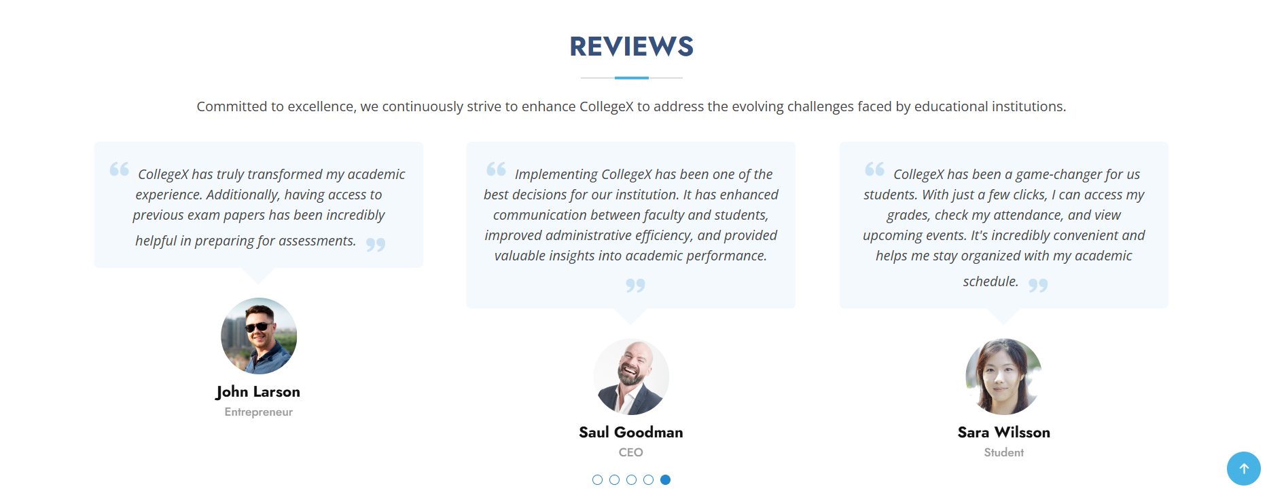



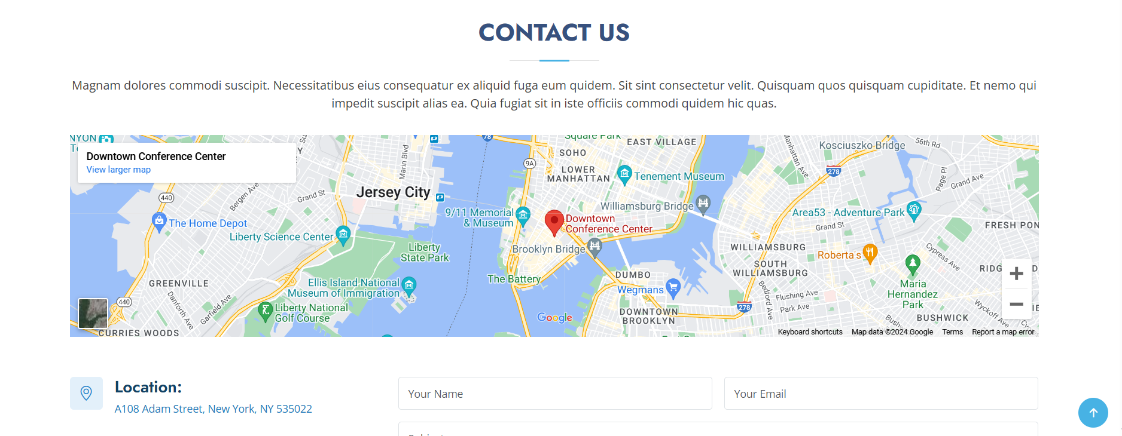
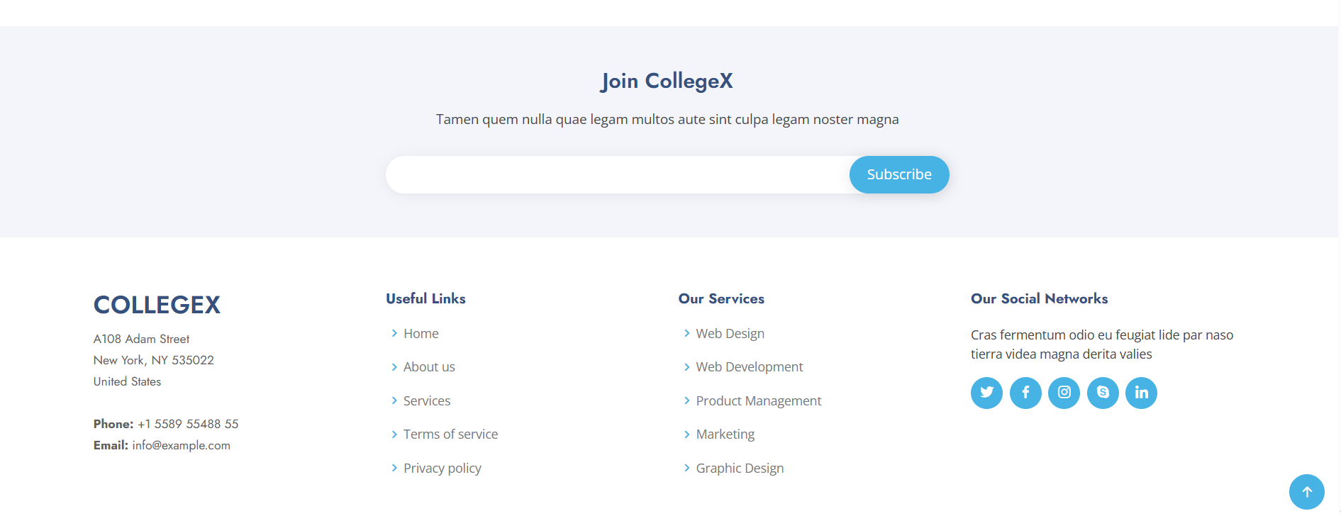

Attendance Page:
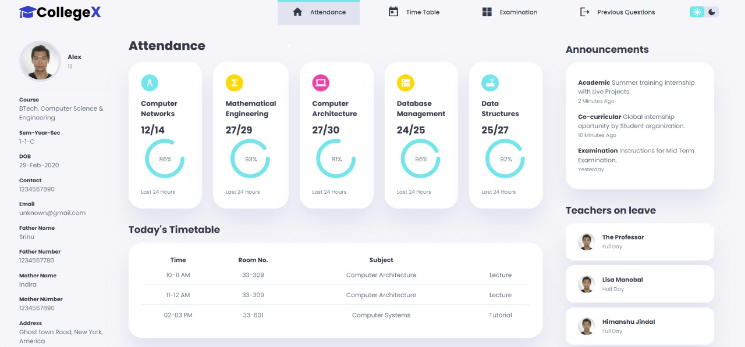

TimeTable Page:

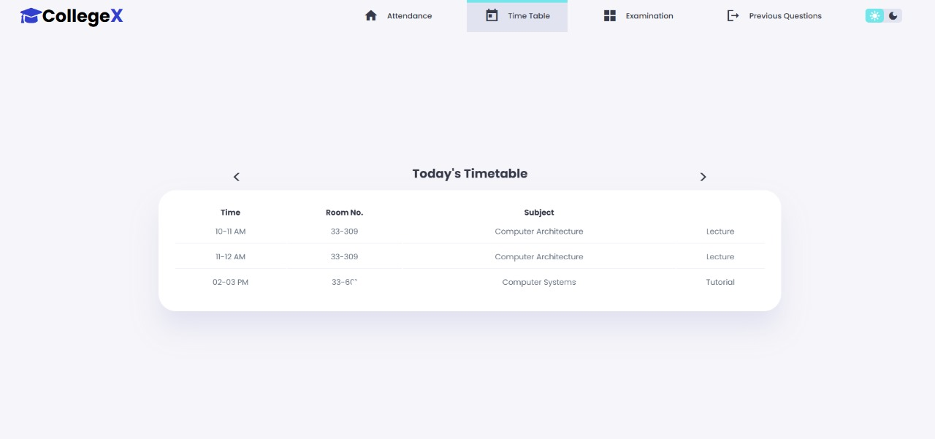

PreviousQuestions Page:
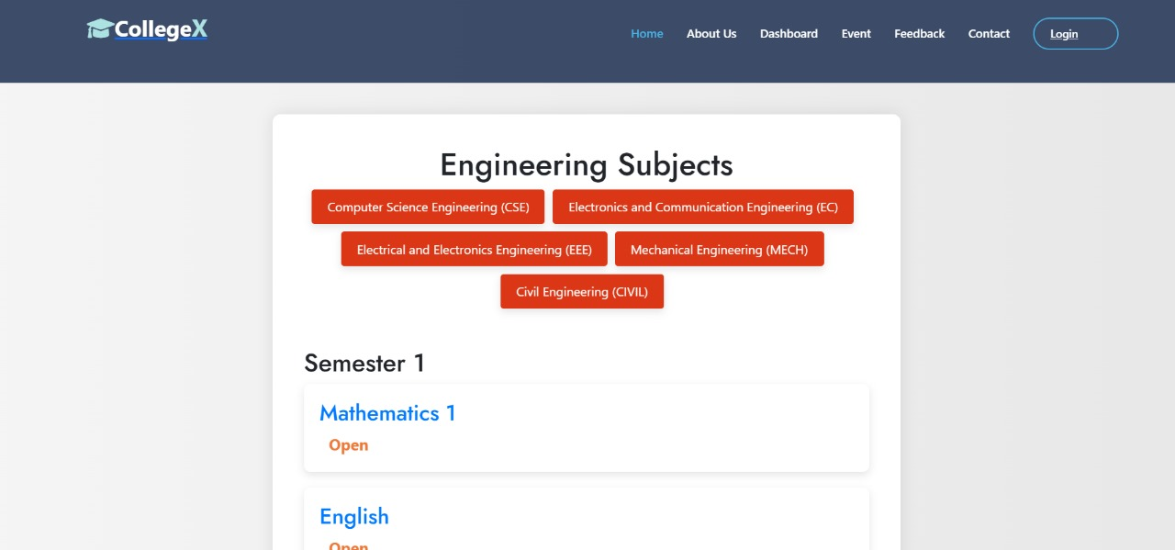

FeedBack Page:
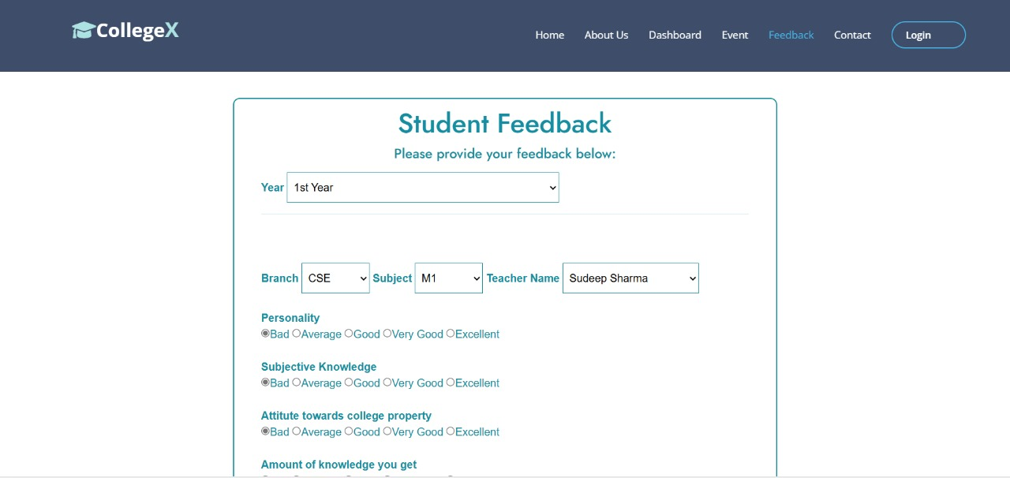

Login Page:
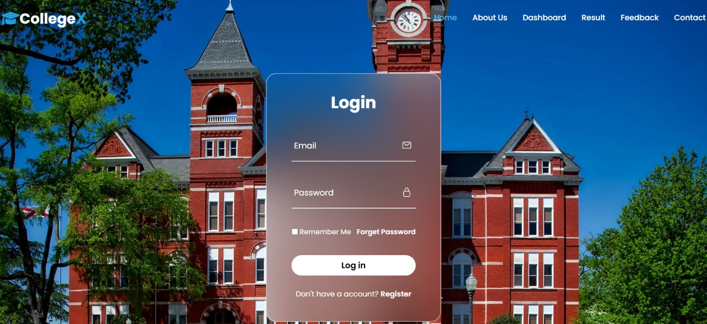

Sign Up Page:

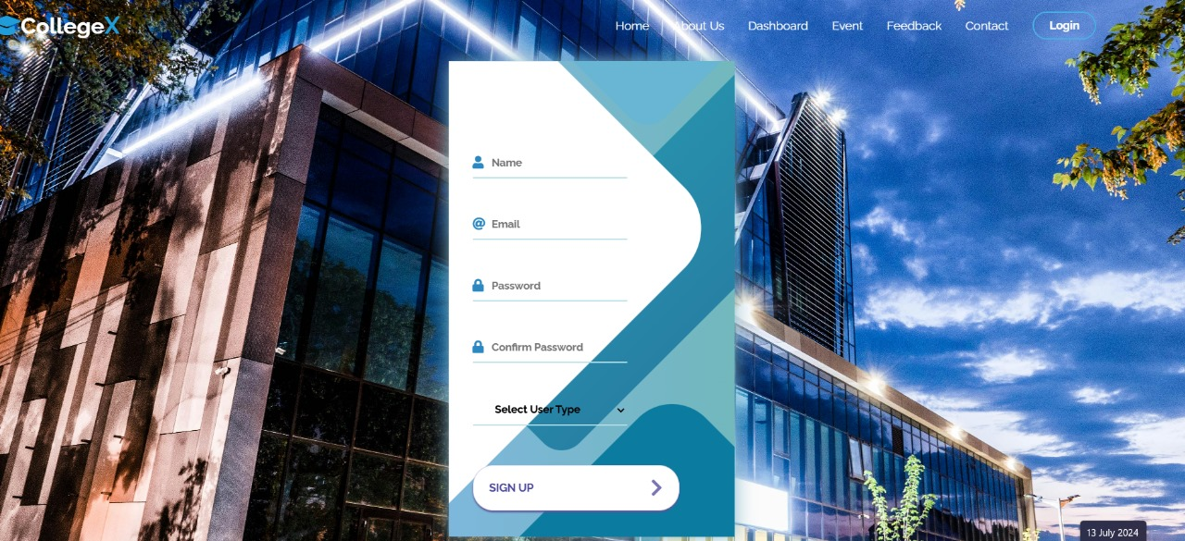

10.CONCLUSION:

In conclusion, College X represents a transformative solution for modernizing college management systems and enhancing the overall academic experience within educational institutions Furthermore. College X is not merely a static solution but a dynamic platform committed to continuous improvement and innovation. In essence, College X is not just a software platform; it is a catalyst for positive change within the realm of higher education. By embracing College X, educational institutions can unlock new possibilities, optimize their operations, and ultimately empower students and faculty to thrive in an increasingly digital and interconnected world.

Moreover, College X is designed with a student-centric approach, prioritizing the academic and personal development of learners. By providing tools for efficient time management, personalized learning pathways, and real-time academic tracking, it empowers students to take control of their educational journeys and achieve their full potential.

Faculty members also benefit significantly from College X, gaining access to comprehensive resources for course management, student assessment, and professional development. This enables educators to focus more on teaching and mentorship, fostering a more enriching and interactive classroom experience.

Administratively, College X enhances operational efficiency by automating routine tasks, improving data accuracy, and facilitating better decision-making through advanced analytics and reporting capabilities. This holistic approach not only reduces the administrative burden but also supports strategic planning and resource allocation.

In essence, College X is not just a software platform; it is a catalyst for positive change within the realm of higher education. By embracing College X, educational institutions can unlock new possibilities, optimize their operations, and ultimately empower students and faculty to thrive in an increasingly digital and interconnected world. It stands as a testament to the transformative power of technology in education, heralding a new era of innovation and excellence in academic management.

11.FUTURE ENHANCEMENTS:

Future enhancements in a college like College X could encompass several areas:

1. Technological Integration: Implementing more advanced learning management systems (LMS), virtual reality (VR), or artificial intelligence (AI) tools to enhance teaching and learning experiences.

2. Curriculum Development: Introducing new programs or courses that align with emerging industry trends or interdisciplinary fields.

3. Facilities and Infrastructure: Upgrading campus facilities, laboratories, and libraries to support modern research and student needs.

4. Student Support Services: Enhancing career counseling, mental health services, and academic advising to better support student success.

5. Global Engagement: Expanding opportunities for international exchange programs, partnerships with global institutions, or increasing cultural diversity initiatives on campus.

6. Sustainability Initiatives: Implementing eco-friendly practices, renewable energy sources, and environmental education programs.

7. Community Engagement: Strengthening ties with the local community through outreach programs, collaborative research projects, or volunteer opportunities.

8. Diversity and Inclusion: Promoting a more inclusive campus environment through diversity training, awareness campaigns, and support for underrepresented groups.

9. Research Excellence: Increasing funding for research grants, fostering interdisciplinary research collaborations, and supporting faculty in their research endeavor

10. Flexible Learning Options: Offering more flexible learning pathways such as online courses, hybrid learning models, or competency-based education.

These enhancements can help College X stay competitive, attract top talent, and provide cutting-edge educational experience for its students.

12.REFERENCES

Books and Journals:
Kothari, C. R. (2004). Research Methodology: Methods and Techniques. New Age International.
Laudon, K. C., & Laudon, J. P. (2019). Management Information Systems: Managing the Digital Firm. Pearson.

Articles and Papers:
- Smith, J., & Brown, A. (2017). "Automating College Management Systems in Educational Institutions," International Journal of Advanced Research in Computer Science and Software Engineering, 7(3), 45-50.
- Lee, Y., & Cheng, C. (2018). "Improving Efficiency of College Management Using Web-Based Systems," Journal of Information Systems Education, 29(1), 12-18.
Web Resources:
W3Schools. (n.d.). React.js Tutorial. Retrieved from https://www.w3schools.com/react/
MySQL Documentation. (n.d.). Retrieved from https://dev.mysql.com/doc/
Mozilla Developer Network. (n.d.). JavaScript Guide. Retrieved from https://developer.mozilla.org/en-US/docs/Web/JavaScript/Guide

Case Studies and Reports:

Case Study: Implementation of an Automated College Management System in Oxford University." (2020). Retrieved from http://example.com/casestudy-oxforduniversity
Annual Report on College Management Systems in Higher Education." (2021). Retrieved from http://example.com/annualreport-2021

